Lesson 06 Demo 03

Setting Disaster Recovery for Azure VMs

Objective: To create a disaster recovery for Azure virtual machines using a recovery
services vault
Tools Required: None

Prerequisites: None

Steps to be followed:
- Enabling virtual machine replication
Step 1: Enabling virtual machine replication

- Sign in to the Azure portal and search for Virtual machines

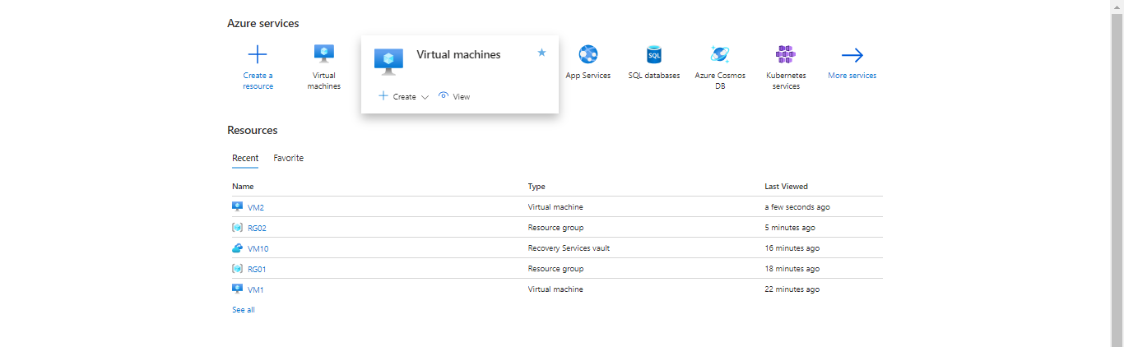

- Click on + Create and then select Azure virtual machine

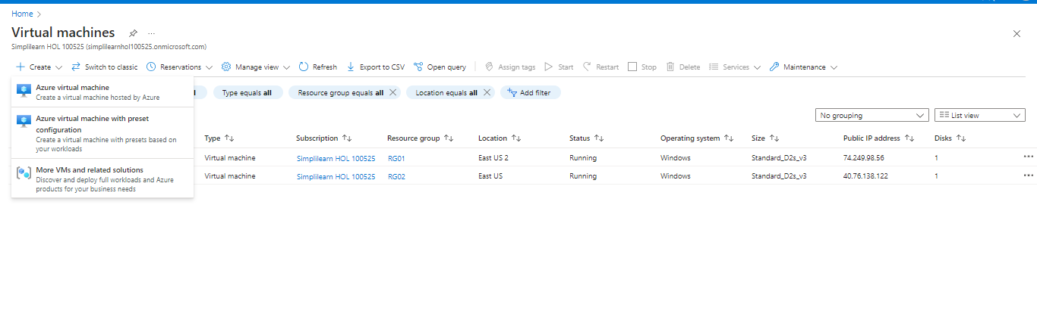

- In the Basics page enter the details as shown below and click on Next: Disks >

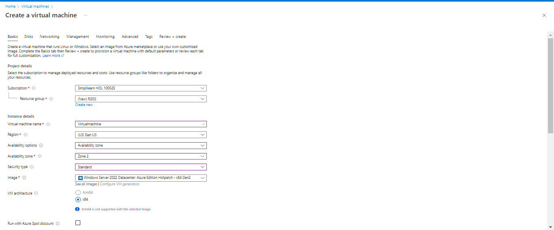

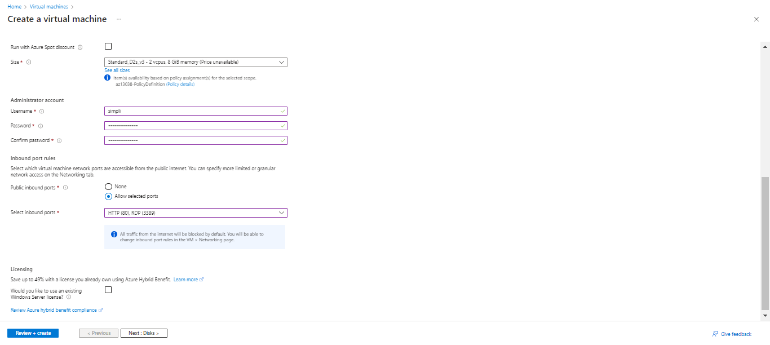

- In the Disks page, enter the following details as shown below and click on Review + create

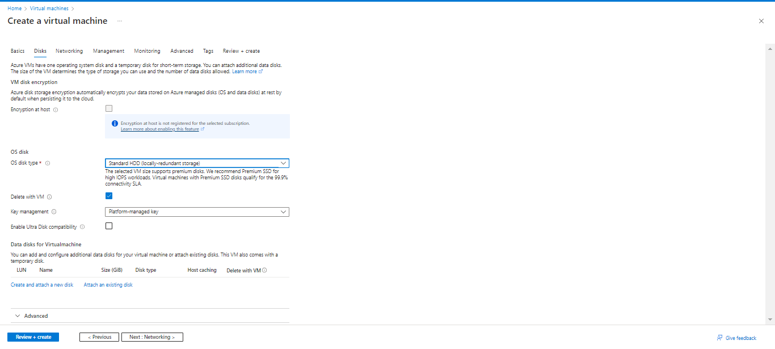

- Then, click Create

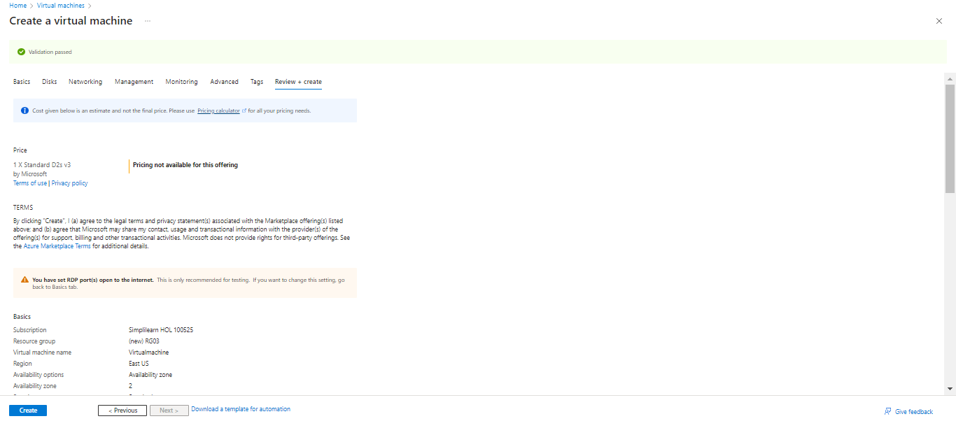

The output appears as follows:

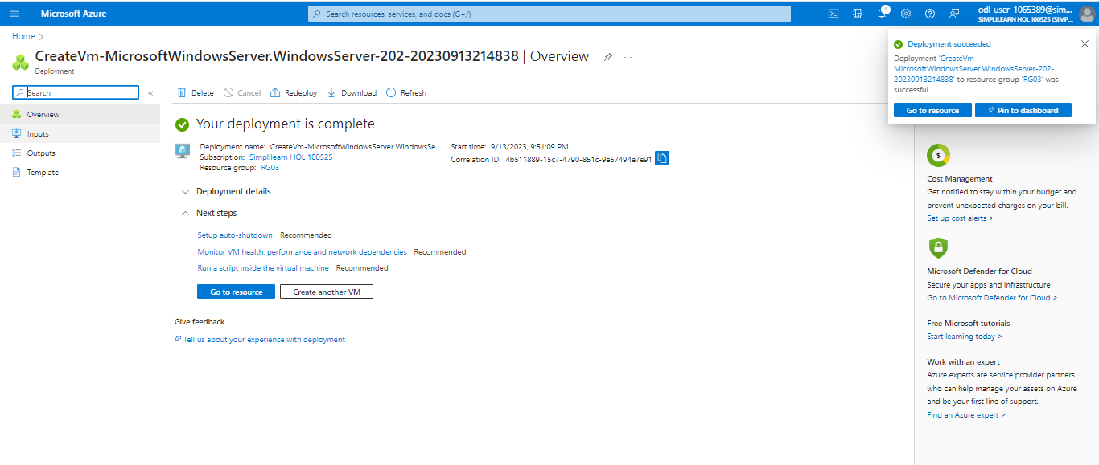

- Search for Recovery Services vaults in the search bar

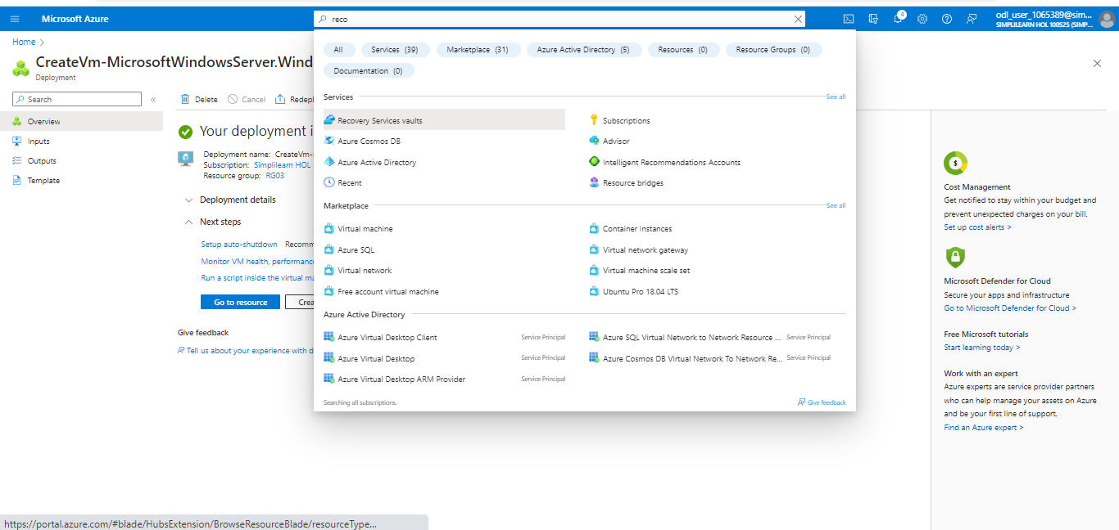

- Click on + Create

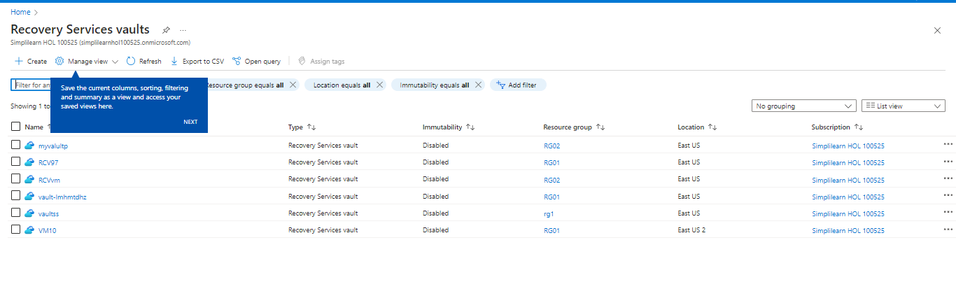

- In the Basics page enter the following details as shown below and click on Review + create

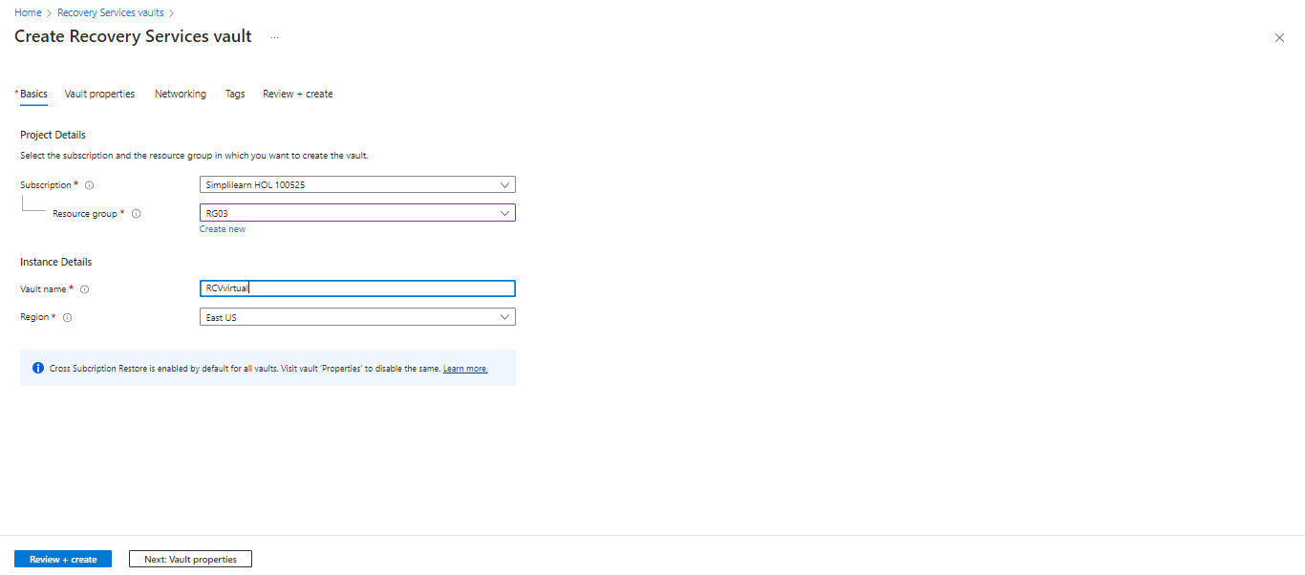

- Then, click on Create

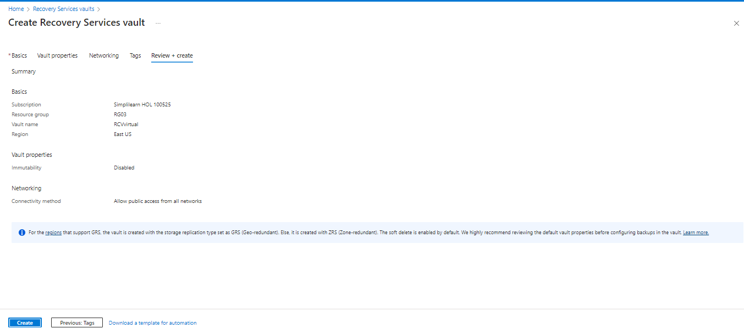

- After the deployment is completed, click on Go to resource

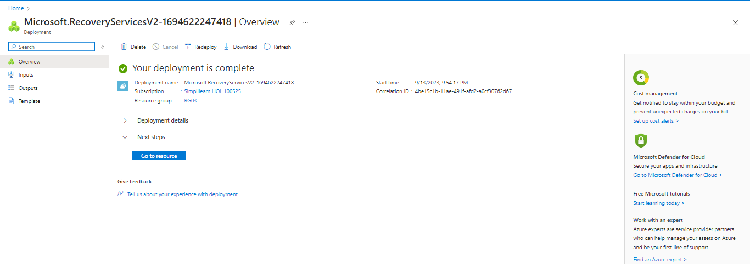

- Click on + Enable Site Recovery

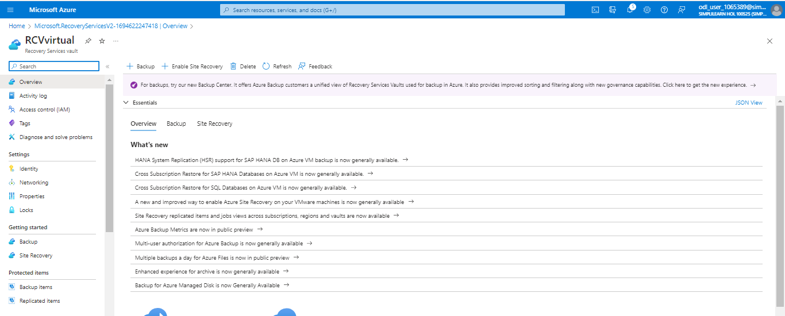

- In the Basics page enter the following details as shown below and click on Review + create



- Then, click on Create



- After the deployment is completed, click on Go to resource



- Locate Site Recovery from the Overview



- Click on Site Recovery and select Enable replication

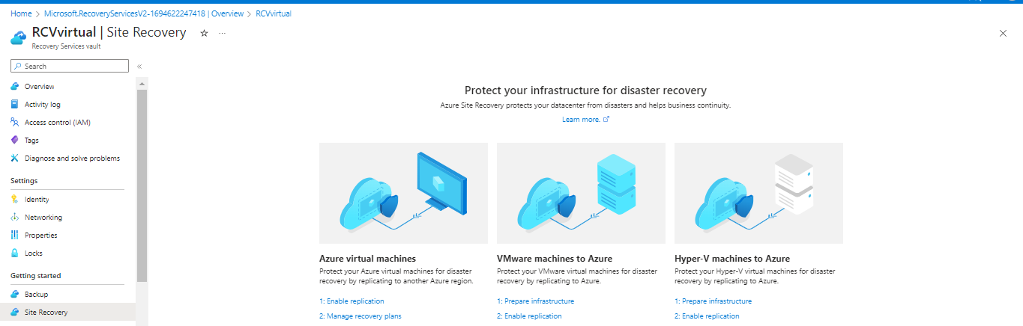

- In the Source page enter the following details as shown below, click on Next

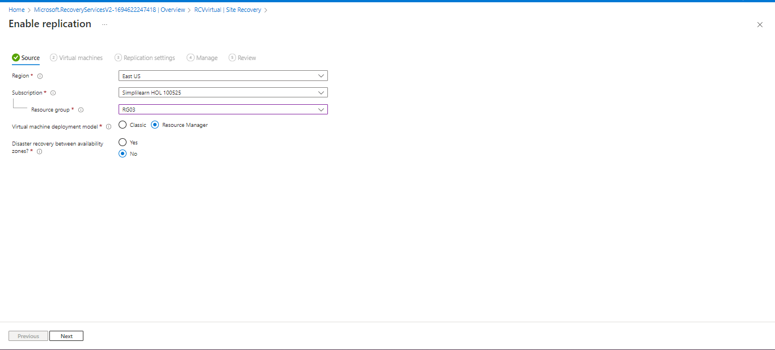

- Select the virtual machine and click on Next

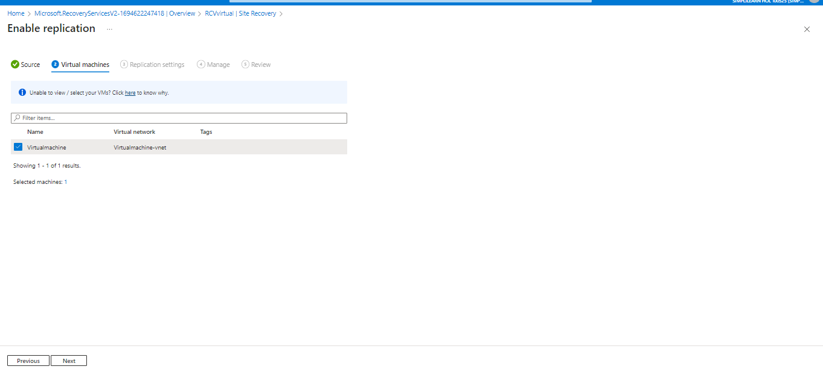

- In the Replication settings page enter the following details as shown below and click on Next

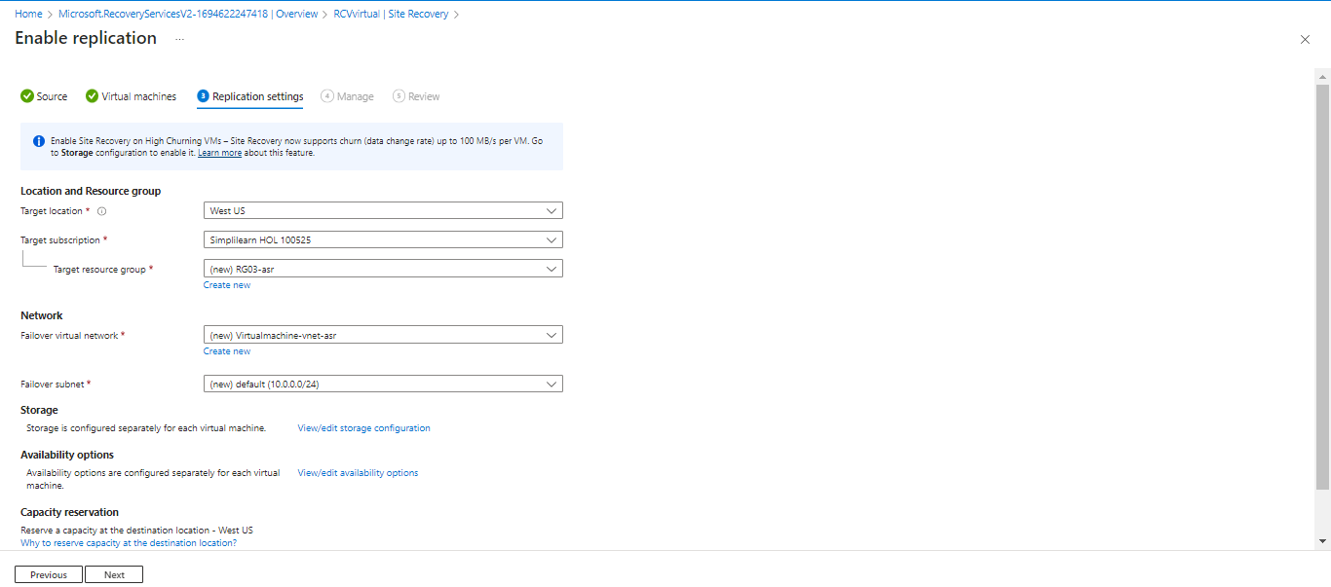

- In the Manage page, enter the following details as shown below and then click on Review

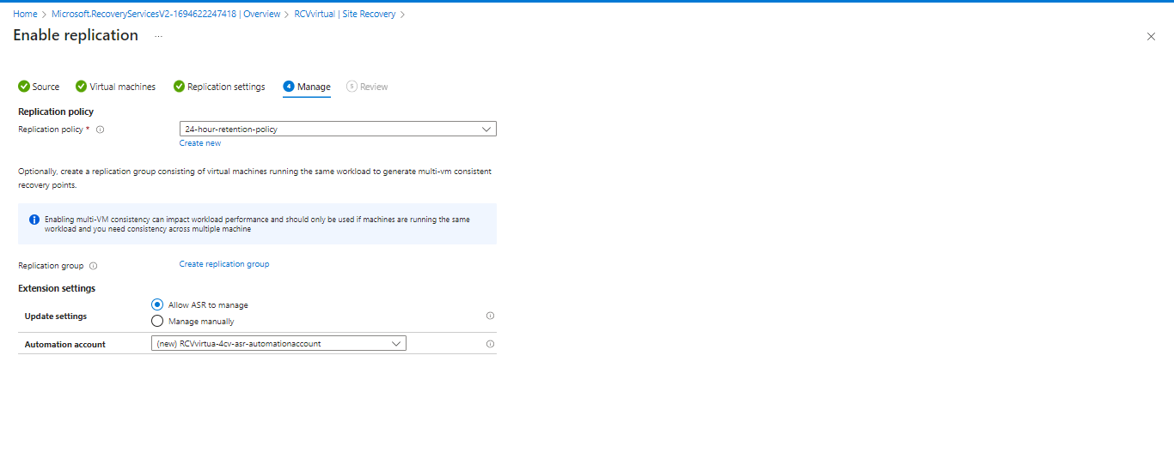

- Then, click on Enable replication

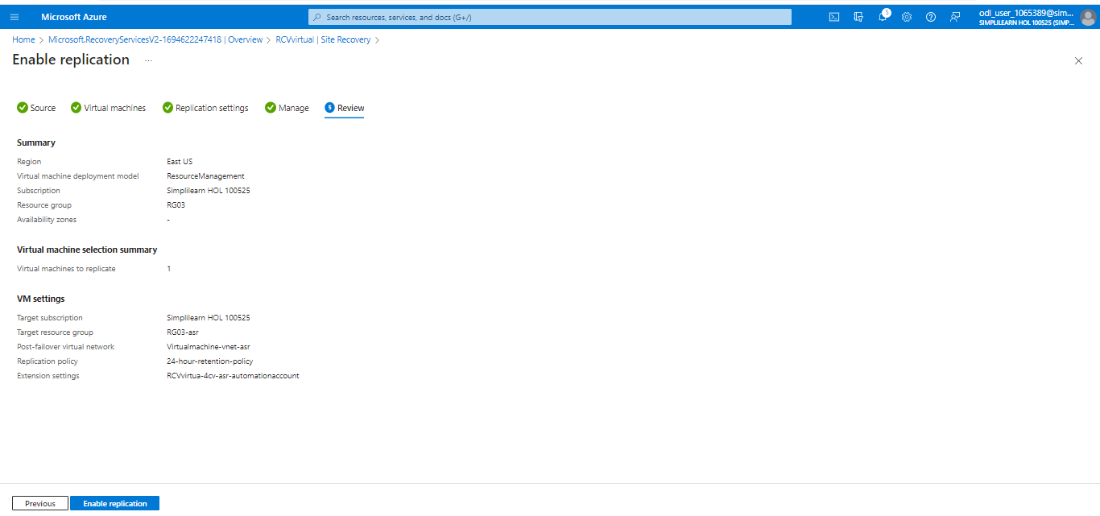

The following screen will appear:

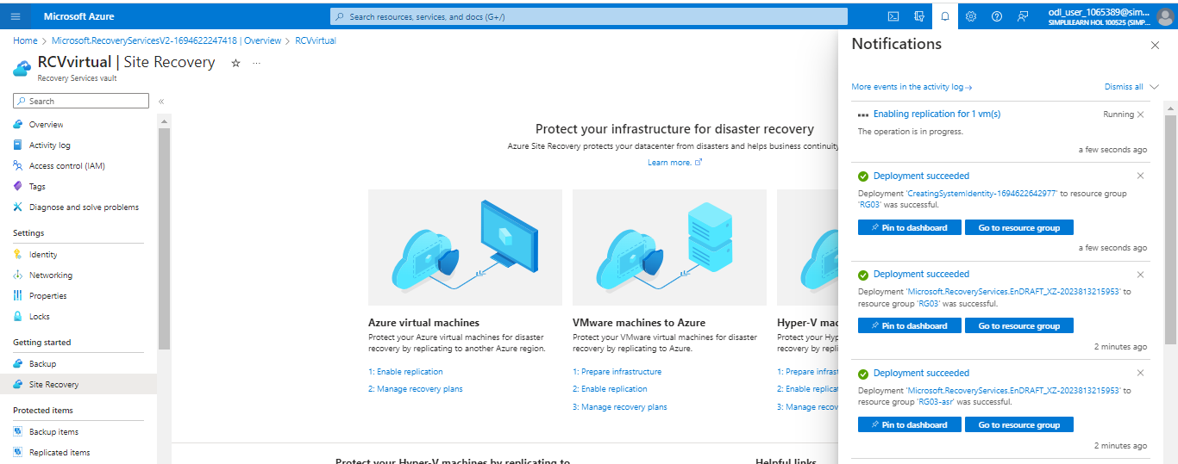

The output appears as follows:

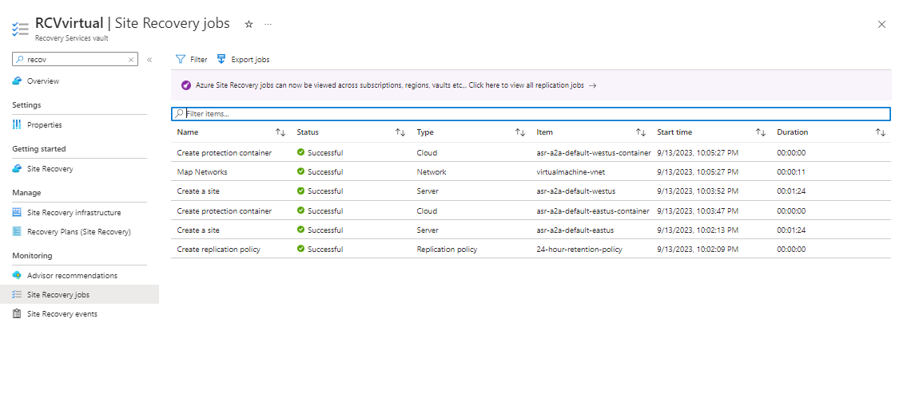

You have now successfully enabled VM replication and set up a disaster recovery solution for your Azure VMs, ensuring the continuity and availability of your virtual machines in the event of a disaster.

